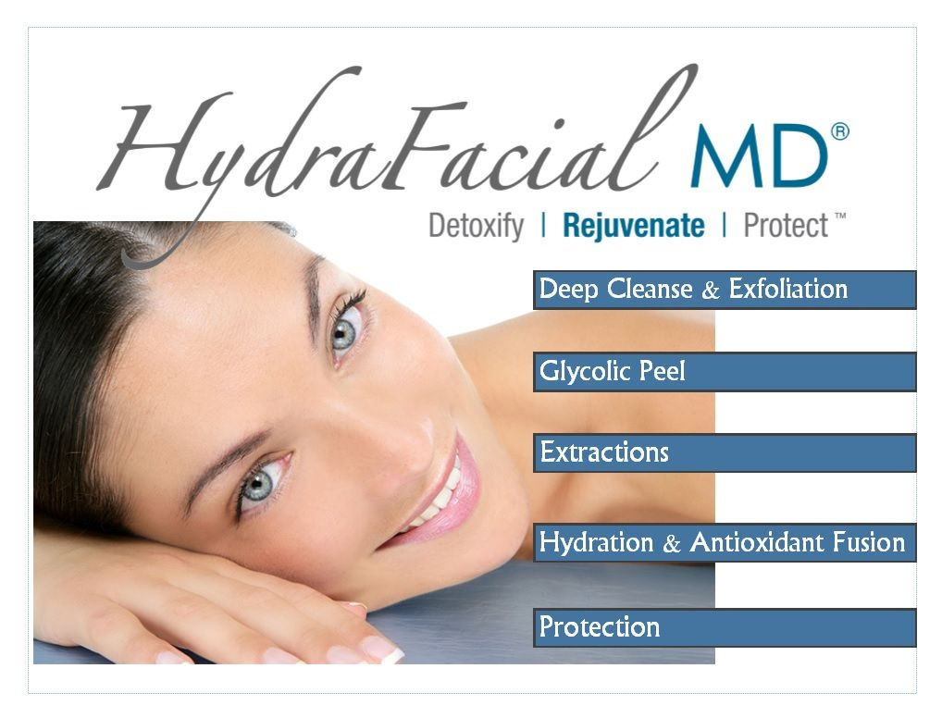
Hydrafacial – The #1 asked for facial in the world!

What is a Hydrafacial
A Hydrafacial is…. An innovative breakthrough in today’s skincare. As the name implies, it hydrates the skin. HydraFacial is a non-surgical, non-invasive treatment that delivers immediate results for improved texture and skin tone without any discomfort or added downtime to recover.
HydraFacial resurfacing addresses every aspect of good skincare by using a combination of cleansing, skin exfoliation, extraction, and eventually hydration along with the added protection of antioxidants and skin rejuvenation.
HydraFacial is a combination of the following three facial treatments:
- Exfoliation and skin resurfacing process of microdermabrasion
- Renewed skin of a chemical peel
- Extractions and hydration similar to a deep-cleansing skin facial treatment
People who use HydraFacial experience instant results leaving their skin more moisturized, soothed, non-irritated, and more attractive.

How HydraFacial Treatment Works
HydraFacial treatment takes a multi-approach to enhance the skin.
- Vortex Extraction – The vortex (strong circulating liquid) can easily extricate and eliminate a variety of skin blemishes including blackheads, sebum, and whiteheads for painless and instantaneous extractions.
- Vortex Cleaning – The unique HydroPeel tip works to hydrate the skin effectively using a nutrient-rich, special solution that deeply penetrates the pores of the skin to dissolve away impurities gently while simultaneously softening the skin.
- Antioxidant Vortex Fusion – The special spiral tip uses a patented approach for using well-hydrated skin solutions as well as infusing strong antioxidants into the skin, which diminishes the appearance of wrinkles, fine lines, hyperpigmentation, and oily skin.
- Exfoliation – Exfoliating the skin is essential in maintaining its health. The HydroPeel innovative tip utilizes its abrasive, multiple edges in order to exfoliate the skin thoroughly many times over to achieve better skin resurfacing minus the irritation, discomfort, and redness

Benefits of HydraFacials
HydraFacial serums are designed to target certain skin problems, such as blackheads, whiteheads, brown spots, acne, sun damage, uneven skin tone, enlarged pores, and the fine lines of premature aging. However, HydraFacial isn’t just a temporary solution to brighter and more beautiful skin. It actually improves the overall quality of skin, which makes it healthier in the long term.

What Does HydraFacial Treat?
- Wrinkles, fine lines, and dehydrated (very dry) skin
- Uneven skin tone, hyperpigmentation, and sun damage
- Enlarged pores, congested pores, acne or oily-prone skin, which is quite common among teenagers and men
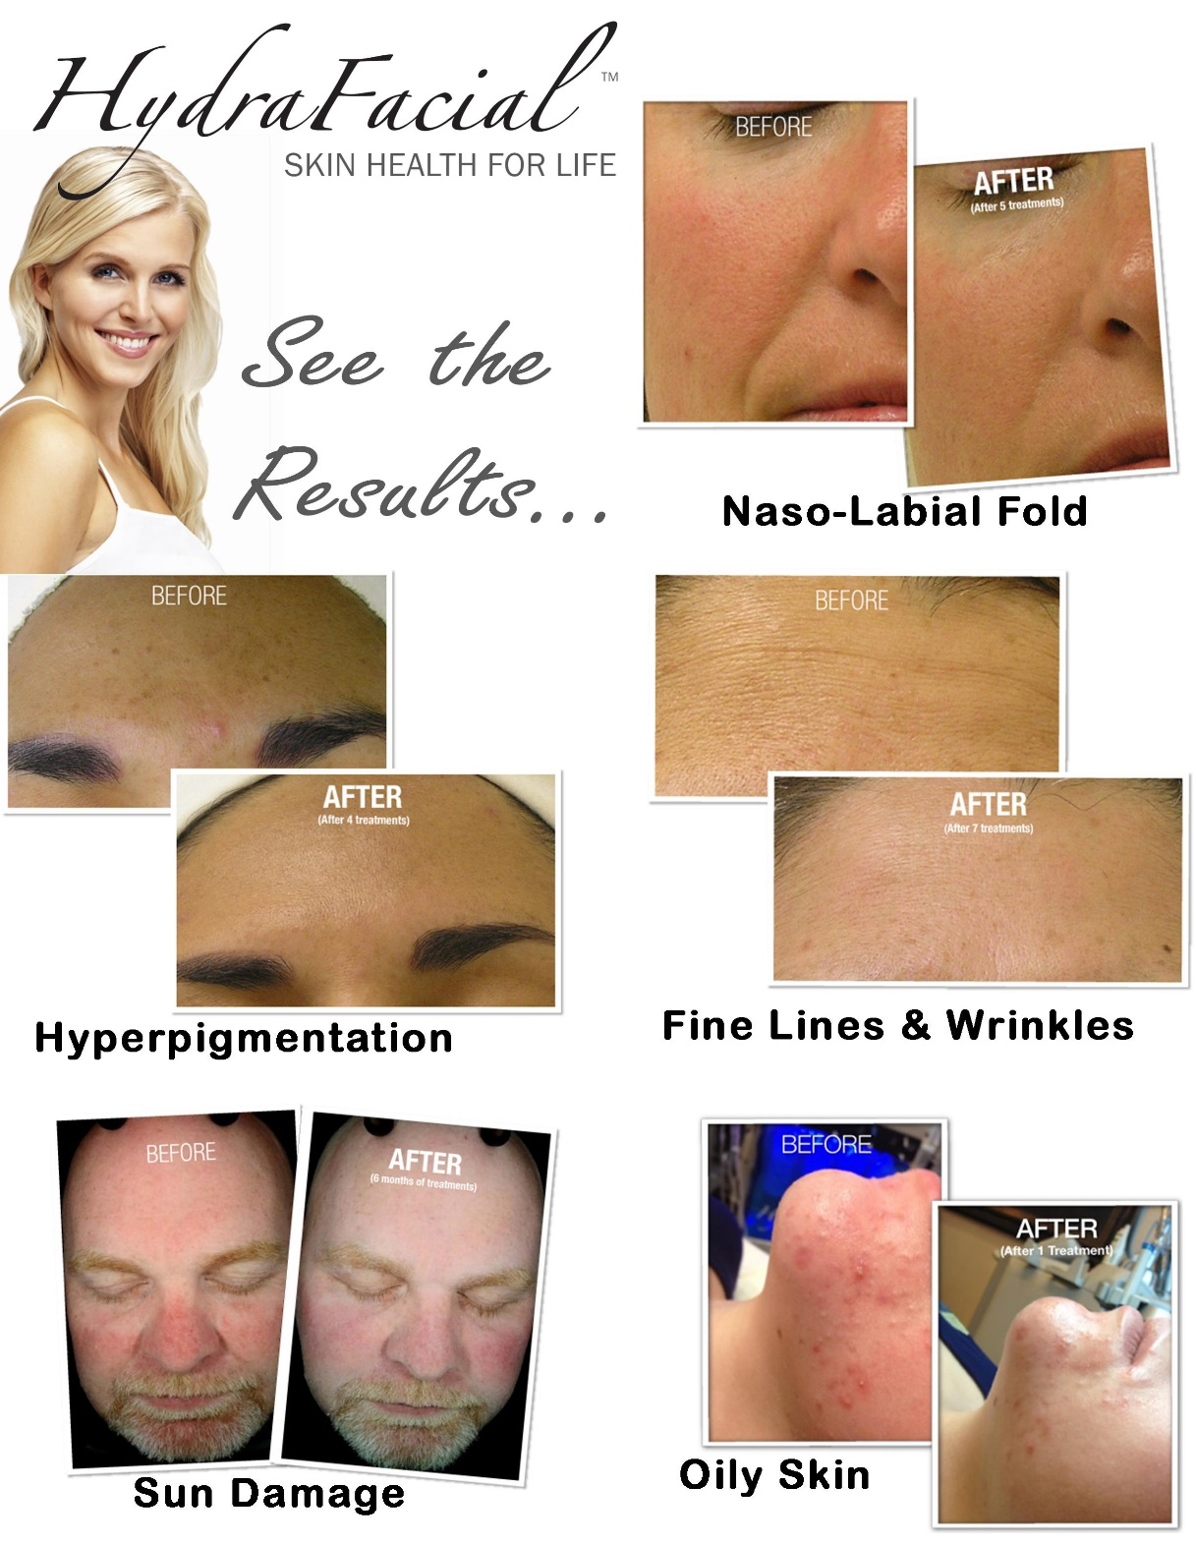

Call today for your appointment today:
Cressy King 703.887.2140 email: cressyking@me.com
Ashburn, VA

